Final Report
Human Resources Task Force
Citizens for Dunwoody
2008


Recruitment of a City Manager
City Manager Search Subcommittee
Mr. Charles Collins, Chair
Ms. Elizabeth Gill
Mr. Dwight Hawksworth
Mr. John Weiss

Contents
1. Executive Summary 3
1.1 City Manager Search 3
1.1.1 Recommended Firm 3
1.1.2 Timeline 3
1.1.3 Estimated Cost 3
1.1.4 Terms 3
1.2 Other Key Position Search 3
2. Introduction 4
3. The City Manager 4
3.1 The Charter 4
3.1.1 City Manager’s Primary Duty 4
3.1.2 City Manager’s Powers 4
3.1.3 Freedom from Interference 5
3.1.4 City Manager Removal Procedures 6
3.2 The Position Description 6
3.3 Availability of Qualified Candidates 8
3.4 Probable Compensation Range 8
3.4.1 Base Salary 8
3.4.2 Value of Fringe Benefits 9
3.4.3 Relocation Expenses 9
4. The Search Process 9
4.1.1 Accelerated Scenario 10
4.1.2 Alternate Scenario 11
4.2 Survey the Council-Elect and Community 12
4.3 Develop a Candidate Profile 13
4.3.1 Education and Experience 13
4.3.2 Skills and Past Performance 13
4.4 The Brochure 14
4.5 Resources 17
5. Search Firms 17

Executive Summary

City Manager Search
Due to the critical requirement for professional city management as soon as possible after the legal formation of a City, the absence of a sitting Mayor and Council, the lengthy duration necessary with part-time community volunteers, and the availability of affordable firms with national reputations specializing in local government executive search, the subcommittee recommends hiring a professional executive search firm in lieu of a citizen committee or Mayoral/Council-led search.

Recommended Firm
The subcommittee unanimously recommends Slavin Management Consultants, as their written proposal was the highest ranked, receiving an average of 4.7 points to the runner up level of 4.3.

Both Slavin Management Consultants and The Mercer Group, the runner up, are excellent firms with depth in the city management search field. The subcommittee rated each proposal at the top of a five point scale on experience, reputation, terms and trust.

The advantages of local availability and higher value presented within the proposal from Slavin Management Consultants were viewed by the subcommittee as the factors differentiating the proposals.

Details of the evaluation process and factor ratings can be found in Section 5 on page 17.

Timeline
Based on the written proposal of the highest ranked firm, the search process can begin immediately with this subcommittee working with the firm t o initiate the development of a profile. If formation of a city is approved by referendum, the firm will continue the search process by interviewing candidates to further develop the profile. The overall process has an expected duration of 90-120 days and will be targeted for appointment at the first City Council meeting.

Estimated Cost
Based on the written proposal of the highest ranked firm the search is estimated to cost between $14,000 and $21,000, depending on expenses of the firm and travel costs of any candidates from outside the area.

Terms
Based on the written proposal of the highest ranked firm, an invoice for fees and expenses will be deferred until the formation of the City and availability of funds. Should the engagement be suspended for any reason prior to completion, Slavin Management Consultants has agreed to invoice for work performed and expenses incurred to date and has provided component pricing as part of their written proposal. Lastly, placement services are guaranteed for two years from the date of appointment. Should the candidate leave, Slavin Management Consultants will conduct a new search for the City Manager.

Other Key Position Search

Again, due to the critical need for a professional city management team as soon as possible after the legal formation of a City, the subcommittee recommends extending the engagement of Slavin Management Consultants for the positions of City Clerk, Police Chief and Clerk of the Court.

Introduction

Citizens for Dunwoody, Inc. was formed in 2004 to investigate both the pros and cons of all the various facets surrounding the issue of whether unincorporated Dunwoody should incorporate as a city. Over the last three years, Citizens for Dunwoody, Inc. has focused attention on the feasibility of a city.

With passage of Senate Bill 82 by the Georgia Legislature, authorizing a referendum on July 15, 2008 for the residents of Dunwoody to vote on incorporation, the mission of the Citizens of Dunwoody continued with a new focus on collection, analysis and dissemination of information regarding what the Operation of such a city may actually entail.

To accomplish this task, Citizens for Dunwoody solicited citizen involvement and formed into 8 Operations Task Forces, including a Human Resources Task Force.

Fifteen volunteers were subsequently subdivided into 4 Subcommittees including a Subcommittee examining City Manager Recruitment Subcommittee. This is the report of the City Management Subcommittee.

The City Manager

The Charter

As signed into law by Governor Purdue on March 25, 2008, the Dunwoody Charter provides power to the Mayor to appoint a City Manager, subject to confirmation by the city council, without regard to political beliefs, and solely on the basis of his or her education and experience in the accepted competencies and practices of local government management. (Section 3.02)

The City Manager serves as the City’s chief administrative officer, devoting all of his or her working time and attention to the affairs of the city. (Section 3.03)

City Manager’s Primary Duty

The City Manager’s primary and broadest duty is to be responsible to the mayor and city council for the proper and efficient administration of the affairs of the city. (Section 3.03)

City Manager’s Powers

In order to carry out this broad responsibility, the Charter (Section 3.04) grants specific powers to the City Manager including:

Power | Description
1. | The power to enforce all laws and ordinances.
2. | The power to appoint and employ all necessary employees of the city, except the city attorney and several other positions optionally appointed by the Mayor including a tax collector, a city clerk, city accountant and city auditor.
3. | The power to remove employees appointed and employed by the City Manager without the consent of the city council and without providing a reason.
4. | The power to exercise supervision and control of all departments and all divisions created in the Charter, or that may be created by the city council in the future.
6. | The power to attend all meetings of the city council, without a right to vote, but with a right to take part in the discussions as seen fit by the chair, or the city council.
7. | The city manager is entitled to notice of all special meetings.
8. | The power to recommend to the city council, after prior review and comment by the mayor, any measure deemed necessary or expedient.
9. | The power to enforce public utility franchise terms and conditions.
10. | The power to make and execute lawful contracts on behalf of the city as to matters within the city manager´s level of authorization as established by the city council to the extent that such contracts are funded in the city´s budget, except such as may be otherwise provided by law; provided, however, that no contract purchase or obligation requiring a budget amendment shall be valid and binding until after approval of the city council.
11. | The power to sign all orders, checks, and warrants for payment of money within the city manager´s level of authorization as established by the city council to the extent that such contracts are funded in the city´s budget, except such as may be otherwise provided by law; provided, however, that no such order, check, or warrant requiring a budget amendment shall be valid and binding until after approval of the city council.
12. | The power to prepare and submit to the city council, after review and comment by the mayor, the city’s annual budget.
13. | The power to advise the city council at all times as to the financial condition and needs of the city;
14. | The power to provide a full written report to the city council on the fifteenth of each month showing the operations and expenditures of each department of the city government for the preceding month, and a synopsis of such reports shall be published by the city clerk;
15. | The power to fix all salaries and compensation of city employees in accordance with the city budget and the city pay and classification plan; and
16. | The power to perform such other duties as may be prescribed by this charter or required by ordinance or resolution of the city council.

Freedom from Interference

The Charter also includes a provision prohibiting City council interference with administration (Section 3.05). Except for special inquiries and investigations, the city council works through the city manager to deal with city employees who report to the city manager. Also, the city council may not give orders to employees of the city manager, either publicly or privately.

City Manager Removal Procedures

Section 3.06 provides that the mayor and city council can remove the city manager only by following specific procedures including:

- Adopting a preliminary resolution and suspending the city manager for no more than 45 days.

- If requested within 5 days, providing the city manager with a prompt public hearing.

- Adopting a final removal resolution.

The Position Description

The Subcommittee surveyed City Manager position descriptions of three comparably-sized and structured local municipalities including Sandy Springs, Alpharetta and Peachtree City.

Based on a review of these position descriptions, the Subcommittee recommends the following 30 items be included in the City Manager position description.

Item | Title | Type | Description
1. | Accountability | Duty | Accepts full responsibility for all City activities, programs, and services including directing the development and implementation of goals, objectives, policies and procedures; ensures that established goals and priorities are achieved.
2. | Goal Setting & Achievement | Duty | Directing the development and implementation of goals, objectives, policies and procedures; ensures that established goals and priorities are achieved.
3. | Provide program advice and consultation. | Duty | Provides advice and consultation to the Mayor and City Council on the development and implementation programs.
4. | Standard Operating Procedures | Duty | Ability to provide effective leadership and coordination in developing solutions, recommending new techniques, and supervising staff procedures.
5. | Strategic Planning | Duty | Serves as a member of senior management on task forces and committees participating in the City’s strategic planning efforts, and addressing citywide policy and management issues
6. | Executive Management | Duty | Confers with department heads and managers concerning administrative and operational problems; makes appropriate decisions or recommendations.
7. | Delegation | Duty | Direct, oversee and participate in the development of the City’s work plan; assign work projects and programs; monitor work flow; review and evaluate work products, methods and procedures.
8. | Implements Council Policies | Duty | Carry out City Council directives.
9. | City or Council Representation | Duty | Serve as a representative of the City, demonstrating a positive attitude and progressive actions through the display of professionalism, courtesy, and appropriate tact and discretion in all interactions with other employees and with the public.
10. | Council Agenda Management | Duty | Prepare agendas, review meeting minutes and prepare resolutions and ordinances for the City Council.
11. | Attend City Council Meetings; and Other Public Meetings | Duty | Attend and participate in all City Council meetings (unless excused by the Mayor or City Council) and other meetings with official bodies as directed by the City Council.
12. | Optimizes Service Delivery Methods | Duty | Reviews and evaluates program and service delivery methods and systems within the City including administrative and support systems and internal relationships; identifies opportunities for improvements.
13. | Ordinance Enforcement | Duty | Oversees the enforcement and administration of the laws and ordinances of the City
14. | Budgeting | Duty | Prepares and submits to the Mayor and City Council an annual budget that reflects the priorities of Council and the community; prepares reports of finances and administrative activities; keeps City Council advised of financial conditions, programs progress, and present and future needs of the City.
15. | Organizational Development | Duty | Continuously monitor and evaluate the efficiency and effectiveness of the City’s organizational structure, staffing patterns, service levels and administrative systems; implement improvements. Provide direction regarding citywide organizational development programs; develop, administer and participate in employee meetings to assess organizational climate and employee attitudes.
16. | Infrastructure Planning & Financing | Duty | Prepares long-term plans of capital improvement with plans for their financing.
17. | Status Reporting | Duty | Keeps City Council advised of programs progress, and present and future needs of the City.
18. | Addresses Problems | Duty | Confers with department heads and managers concerning administrative and operational problems; makes appropriate decisions or recommendations.
19. | Receives Public Input | Duty | Confers with residents, taxpayers, business, and other individuals, groups and outside agencies having an interest or potential interest in affairs of City concern.
20. | Maintain Professional Currency | Duty | Attends and participates in professional and community meetings as necessary; stays current on issues relative to public administration and relative service delivery responsibilities; responds to sensitive and complex community and organizational inquiries and complaints.
21. | Addresses Complaints | Duty | Respond to citizen inquiries and resolve difficult and sensitive complaints; assign departments to handle and resolve citizen complaints and concerns in a timely manner.
22. | Sustains External Relationships | Duty | Serve as liaison between the City and other cities, counties, elected officials and outside agencies; explain and justify City programs, policies and activities; negotiate and resolve significant and controversial issues.
23. | Chief Procurement Officer | Duty | Oversees outsourcing of services rendered through contract administration
24. | Broad Responsibilities | Duty | Performs related work as required.
25. | Education | Qual | Master’s Degree in public administration, business administration or related field.
26. | Experience Duration | Qual | Ten years experience of progressively responsible management experience in the planning, organization, coordination, and administration of varied municipal activities, of which six years at the executive level or any equivalent combination of training, education and experience, which provides the individual with the required knowledge, skills, and abilities to perform the job.
27. | Management Experience | Qual | Proven track record of planning, organizing, and managing the activities of the city under the policy guidance and direction of the elected officials of the City. Manage and provide organizational leadership.
28. | Knowledge of City Functions | Qual | Knowledge of the principles and practices of public dministration, organization and functions of City government and current trends and recent developments in management, law and regulations regarding City management, City contracts for public services, budget, finance, and public personnel administration.
29. | Communication / Presentation Experience | Qual | Extensive background in making presentations to a variety of stakeholder groups.
30. | CM/Assistant/Deputy Manager Experience | Qual | Experience as an Asst City Manager.

Availability of Qualified Candidates

Based on interviews with 2 search firms and 1 former city manager, because of the high probability of significant contract service delivery, enabling a City Manager to focus on Council matters, and the high-quality of life in Dunwoody/the Atlanta Region, there is likely to be strong interest from experienced City Managers throughout the U.S.

With 250-300 municipalities and 159 Counties in Georgia alone, there are likely to be 10-15 Georgia candidates with a likely qualified candidate flow of 50-75.

Probable Compensation Range

Due to the relatively higher cost of housing in the Dunwoody area in relation to other areas of Georgia and the Southeast, , the probable total compensation package , including fringe benefits, retirement and allowances, is estimated to range between $195,000 and $255,000 per year. If a relocation is necessary, an additional $50,000 in expense is possible depending on the originating location and the need for temporary housing.

Base Salary

The base salary is estimated to range between $140,000 and $190,000 annually.

As a reference point, the subcommittee used data from an annual survey of state municipalities conducted by the Georgia Department of Community Affairs (DCA). The DCA surveys municipalities on a wide range of information, including the salaries of City Manager positions. The average salary of the 8 “Group B” (population between 30,000 and 50,000) cities was between $102,450 and $137,878.

Based on the relatively higher cost of housing and the career risks inherent in a start-up city, the subcommittee believes that while the applicant flow will be sufficient, the value of the highest-rated candidates will require a “premium” of between 25 and 40 percent over the “Group B’ cities in the DCA survey.

 | 2006 Population | Minimum Salary | Maximum Salary
Valdosta City | 45,529 | $ 160,000 | $ 160,000
East Point City | 42,204 | $ 94,866 | $ 147,991
Rome City | 36,142 | $ 132,317 | $ 132,317
Gainesville City | 33,340 | $ 124,051 | $ 124,051
Dalton | 33,045 | $ 61,445 | $ 93,093
Kennesaw City | 30,936 | $ 84,074 | $ 127,428
Hinesville City | 29,554 | $ 77,971 | $ 190,832
Smyrna City | 28,632 | $ 84,874 | $ 127,312
Average | 34,923 | $ 102,450 | $ 137,878

Value of Fringe Benefits

The value of fringe benefits are estimated to range between $55,000 and $65,000.

Assuming the value of family health coverage in the range of $12,500 and the value of other potential allowances, such as a vehicle or housing allowance, the estimated fixed benefit value is approximately $22,500. Additionally,wage-driven benefits, including FICA and a retirement contribution are estimated to total 21.65 percent of wages.

 | Benefit Level
Health Care | $ 12,500
Allowances | $ 10,000
FICA | 7.65%
Retirement | 15.00%

Relocation Expenses

If necessary, relocation expenses are anticipated to range between $40,000 and $50,000 depending on the distance relocated.

The Search Process

Based on written proposals, whether using an executive search firm or launching a search independently, the process begins by meeting with the candidates for office or elected officials both individually and as a group if possible, to help them decide what they are looking for in a new administrator.

It is the firm's responsibility to facilitate these discussions and to help reach a consensus on such items as desirable work experience, management style, timing and scope of the recruitment, and compensation. After these matters have been reviewed, the firm coordinates the overall recruitment process and assumes responsibility for all tasks until it is time for the elected body to select and interview finalists. The committee or firm acts as a resource throughout the entire recruitment process.

As advised by the ICMA, Councils using the services of an executive search firm should make certain they select a reputable firm familiar with the special requirements of local government administration.

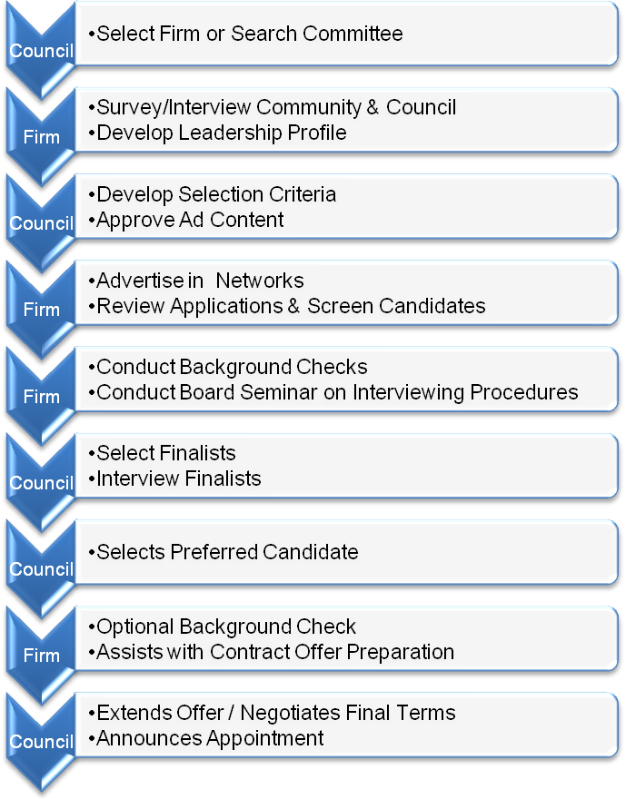

Based on consultations with several search firms and city managers, the search process for Dunwoody will have a duration of three to six months depending on the level of organization and unanimity of the Council, the capabilities of the firm, and the availability of all parties.

Accelerated Scenario

The subcommittee recommends adopting an accelerated approach. The timeline would begin as soon as possible with effort ramping up just after referendum passage, yet prior to Council election. In this approach, the Citizens for Dunwoody should retain a search firm and establish a committee to initiate the search in advance of city launch. The search firm should survey and interview all candidates for Council and Mayor, synthesizing all input into a prospective Council vision.

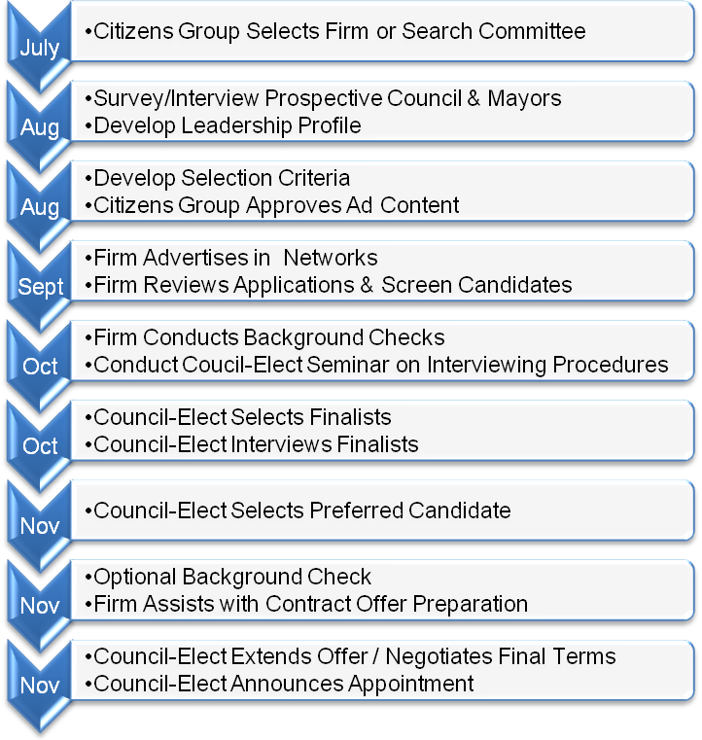

Alternate Scenario

In this scenario, finalists are interviewed in early January with an on-boarding target date of February 16, 2009.

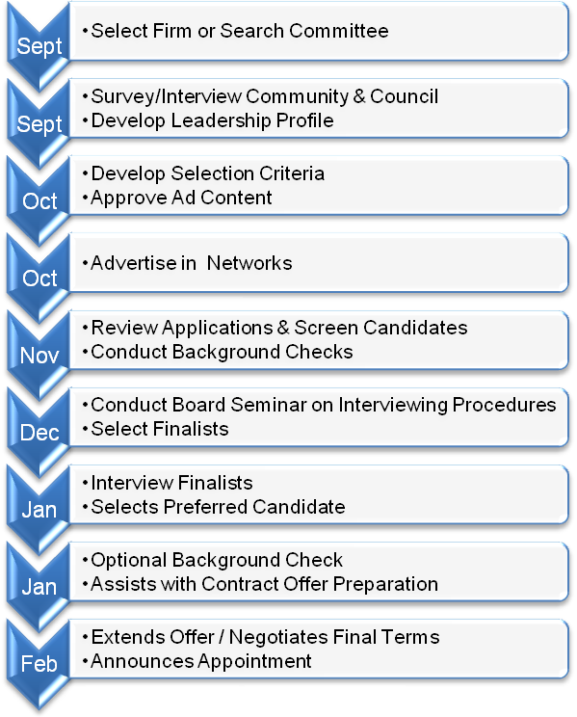

Survey the Council-Elect and Community

The initial step will be to interview the Council and Community Representatives for the purpose of developing a leadership profile. A survey instrument such as the one below from the ICMA is recommended.

Describe the background, skills, and qualities you feel the City of Dunwoody needs in an administrator.

Rate the general importance of each item by high, medium or low.

Num | Criteria | Rating
 | General
1. | Relevant Education
2. | Relevant Experience
 | Skills and Past Performance
3 | Council Relations
4 | Community Relations
5 | Intergovernmental Relations
6 | Economic Development/Revitalization
7 | Innovation/Major Achievements
8 | Administrative Ability
9 | Written and Oral Communication
10 | Budget/Financial
11 | Information Technology
12 | Human Resources
13 | Risk Management
14 | Benefits Administration
15 | Infrastructure and Facilities
16 | Contract Administration

Develop a Candidate Profile

Education and Experience

A master’s degree or equivalent experience in local government is required with a minimum of ten years of public administration experience, with five years as a city manager preferred.

Past local government experience of individual must show performance in areas that include budgeting and finance, human resource management, information technology, risk management, grants procurement and administration, economic development strategies, understanding of state laws, and other related matters including land use planning, zoning regulations, engineering, and public works. Prior Georgia experience preferred. Experience and knowledge in local government accounting is desirable.

Skills and Past Performance

Administrative Ability.

Must have demonstrated performance in human resources and/or collective bargaining for a community having not less than 10 employees. Good communication skills are a must, including the ability to listen, communicate with various segments of the community, and develop good relations with the business community. Person must be willing to devote whatever time is necessary to achieve the goals and guidelines established by the council. Knowledge of how to organize departments and demonstrated leadership qualities are desirable.

Council Relations.

Ability to take time and interest in working with council members to keep them informed and explain technical processes. Should be able to adequately inform the council on a regular basis so there are no surprises. Both written and oral communications with the council are essential. The person must be able to accept constructive criticism and to implement the needed changes. Candidate must be open and honest with the council and able to present all sides of an issue that affect the locality. The individual must be able to carry out the intentions and directions of the council enthusiastically.

Community Relations.
Candidate must have demonstrated involvement in community activities. Experience working with and understanding the needs of the business community is highly desirable. Candidate should be able to present a confident image of the local government to the community at large. Must be able to demonstrate a positive, productive attitude to citizens of the community.

Intergovernmental Relations
Must be able to relate to and develop a good working relationship with other local governments, county governments, community organizations, schools, and state and federal agencies.

Contract Management
Must have some knowledge of Georgia procurement law, with preferred demonstrated ability in broad business process outsourcing. Must have demonstrated ability to manage complex contractual relationships.

Budget and finance
Should have demonstrated prior experience in managing a city or county budget. Experience and expertise in grant procurement is desirable, as well as dealing with locally-owned utility finances.

Human resource management
Must have some knowledge of Georgia labor relations law. Must demonstrate a personality that can communicate the local government’s goals and needs to employees.

The Brochure
Based on other recruitments by national search firm, the brochure for the Dunwoody City Manager could appear like the sample below.

City Manager
Dunwoody, Georgia
The Community and Location
Welcome to Georgia’s newest City! Above all else, Dunwoody is a community. Yes, its location is ideal – 30 minutes from downtown Atlanta and 60 minutes from the Georgia mountains. The City is extremely attractive. In many ways, it reminds a visitor of an English village. Yes, its schools are excellent. Its four elementary schools, one middle school and one high schools are all “A” rated. Crime is low and very, very little is violent. Most arrests are generated through traffic stops. The population of 40,000 is well educated and affluent (median income is $82,500). It is also spread fairly evenly among age groups.
But what makes Dunwoody special is that it is a community. It has a “your town” feel. Volunteerism is high. People are friendly, warm and care about each other.
The City is 12 square miles and fully built out. Opportunities for annexation are limited. But that does not mean that Dunwoody is a sleepy little hamlet. As it developed, it planned ahead. The residential section is east of Ashford-Dunwoody Road with a commercial class A office “downtown” to the west. The Perimeter Center, as it is called, has several million square feet of office space and 10,000 people work there each day. In fact, 30% of the City’s property tax revenues come from non-homestead sources. And further targeted development is planned.
The Government
The City follows the Council-Manager form of government with a Mayor and six Council Members serving staggered two-year terms with three seats by district and 3 seats elected at large. Elections for the new Mayor and Council members are underway. The candidates are intelligent, cooperative, collegial, and progressive. They sincerely want the best for their community and serve because they want to give back to their community. They are also strong proponents of a responsive, open, customer friendly government.
The City will launch in good financial health with the total assessed value for properties in the City is $2.5 billion and an operating tax millage in a modest range. The estimated budget for FY 2009 is $18.0 million with a general fund budget of $12 million. The City is expected to have a minimum number of fulltime employees. With the exception of police services, most city services (planning & development, code enforcement, street maintenance and storm water management) are expected to be delivered through a contract.
The Opportunities
Dunwoody, like any other city, has its opportunities. The good news is that they are manageable. These opportunities include:
Creating Community. As a new city, Dunwoody presents city management professionals with a rare opportunity to play a significant role in bonding the existing civic organizations to the new city and creating new civic infrastructure as necessary for sustaining an engaged, progressive citizenry.
Financial. With softness in housing values and defined sales tax options, meeting service delivery expectations in a start-up environment will require financial ingenuity and a grounding in sound financial policy, budget development and management.
Targeted Economic Development. As noted above, while development in Dunwoody has slowed, residential infill and commercial growth remains relatively substantial. However, the City will be faced with the challenge of immediately building a pipeline of targeted economic development opportunities to assure a sustainable tax base.
The Perimeter Center. Area began in the early 1970s, the Dunwoody Center Area has been the economic engine that drives city finances. Class A office space does not always, however, remain Class A without some effort. The City is working with the property owners and managers to determine what it can do to assist in maintaining the designation.
Succession Planning. A number of key department directors will retire and leave the City in the next five years. In most cases, successors are not immediately apparent.
Infrastructure. While the City’s infrastructure is in relatively good condition, it will need rehabilitation within the foreseeable future.
The Ideal Candidate
Dunwoody it is looking for an experienced, knowledgeable manager who is creative, enthusiastic, entrepreneurial, progressive and proactive. The individual will be receptive to new ideas, very customer service oriented, outgoing and friendly. He/she will be a real people person who is highly ethical, comfortable dealing with people from all walks of life and experienced in managing with limited resources. The individual will have a demonstrated track record of success and achievement. He/she will be a leader, inspirational and strongly believe in teamwork. The ideal candidate will be an excellent listener and communicator who will keep the elected officials, staff and residents well informed. He/she will be candid and treat all the elected officials fairly and equally. Transparency in local government will be an important value for the next manager. He/she will also be comfortable speaking openly and candidly with Council and will be able to provide explanations for recommendations. Other important characteristics are being fiscally conservative, media savvy, being able to anticipate and prepare for the future and knowledgeable of technology. Good judgment is essential. The manager will have a competent staff and will not micromanage them but will hold the staff accountable for results. Experience dealing with developers and large developments is important. The position requires a bachelor’s degree in business administration, public administration, public policy or related field and 7 to 10 years of increasingly responsible experience in the public sectors. A master’s degree is preferred. ICMA Credentialed Manager and Georgia experience are a plus.
Compensation
The starting salary will be between $140,000 and $190,000 with an attractive benefit package.
How to Apply
E-mail your resume to recruiter@dunwoody.com by September 30, 2008. Faxed and mailed resumes will not be considered. Questions should be directed to Slavin Management Consultants.
The Process
Applications will be screened between October 1st and 30th. The Council-Elect will select finalists on November 1st. Finalist interviews are scheduled for November 1 through 30. A selection of the city manager is to be made on November 15th with a vote by the City Council on December 1st.
Other Important Information
Residency in the community is strongly preferred but not mandatory if approved by Council.
Dunwoody is an Equal Opportunity Employer and encourages minorities to apply. Under the Georgia Public Records Act, all applications are subject to disclosure upon receipt. Veteran’s preference will be awarded under applicable Georgia law.

Resources

Elected officials in search of an administrator will find a variety of resources available to assist in the recruitment process. These include:

Others having an interest in local government. College or university faculty members, institute of government staff members, local government consultants, and community leaders also may be able to provide leadership and assistance with some part or all of the recruitment process.

Current and former local government officials. Local government officials in adjacent communities or retired local government officials are a good resource for assistance. For example, a neighboring local government official could assist a search firm, and a retired official could coordinate the recruitment process.

Search Firms

Through online and field research, the subcommittee identified 5 organizations likely to be well qualified to conduct the search. Through telephone and in-person interviews, the subcommittee qualified three organizations as best qualified to meet Dunwoody’s requirements including The Mercer Group, the Carl Vinson Institute of Government (CVIOG) and Slavin Management Consultants.

The subcommittee solicited formal written proposals from each organization. Owing to their public status, the CVIOG has a longstanding policy to not compete with private firms and declined to submit a proposal.

The subcommittee interviewed Slavin Management Consultants and The Mercer Group, two nationally-recognized executive search firms specializing in the local government industry, and solicited formal written proposals from each.

The subcommittee rated each of the two written proposals on a five point scale across eight equally weighted factors as displayed on the following page.

