These JPEG’s are directly from the EPA Safe Drinking Water Website on EPA.gov.
Coliform Bacteria
Information from EPA Website
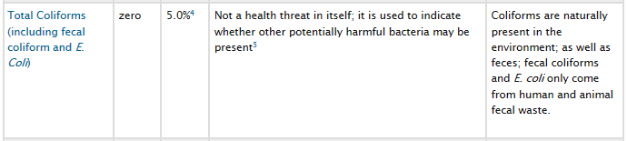
⁴ No more than 5.0% samples total coliform-positive (TC-positive) in a month. (For water systems that collect fewer than 40 routine samples per month, no more than one sample can be total coliform-positive per month.) Every sample that has total coliform must be analyzed for either fecal coliforms or E. coli if two consecutive TC-positive samples, and one is also positive for E.coli fecal coliforms, system has an acute MCL violation.
⁵ Fecal coliform and E. coli are bacteria whose presence indicates that the water may be contaminated with human or animal wastes. Disease-causing microbes (pathogens) in these wastes can cause diarrhea, cramps, nausea, headaches, or other symptoms. These pathogens may pose a special health risk for infants, young children, and people with severely compromised immune systems.
The DeKalb County Consumer Confidence Report for 2013 shows the following results from thousands of tests throughout the County and year:
Total Coliform |  | DeKalb Results, 2013
Test Reporting Unit | Presence/Absence Sample Count | 0.19% of all samples taken had Presence
Detection Range | BDL (Below Detection Limit) to Present | BDL to 1.04% positive in a sample group
Regulatory Limit | Less than 5% per month Presence | 0.19% is below the regulatory maximum of 5%
Retest | Test used also detects E. coli and testing is positive again | Compliant with absence
Coliform bacteria are a group of similar bacteria that occur naturally throughout nature. There specific presence can indicate a potential contamination event and is more sensitive than a HPC test along with being a little more specific for potential human problem. These organisms occur naturally in dirt, certain food products like bean sprouts, and on fresh produce, etc.
Most coliform bacteria are not significantly harmful and bacteria, being the way they are react to testing the same as the harmful types of coliform bacteria. The two types of harmful bacteria are fecal coliform or a specific coliform, E. coli.
When we conduct our Total Coliform testing if the initial reading is positive we continue the test to determine if it is a harmful coliform bacteria as well as go get a repeat sample from the same location along with a sample from up and down stream of the site to use in determining if it is a site specific problem or a system issue. Keep in mind that bacterial testing requires the initial set-up time, a 24 hour incubation period and additional time for any additional positive testing.

Heterotrophic Bacteria
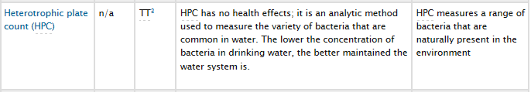
These bacteria can indicate subtle changes in the system that might be precursors to larger problems, issues with the sampling site tap that could be recent cleaning, contamination from an external source or similar activity, and in sites using a home water treatment unit a failure in or consumption of the system’s ability to treat water.
These are not single event indicators and have to be viewed over time in the system. We also use them in conjunction with the coliform testing to help us judge system condition.
There is no contaminant level for these and a guideline is 500 CFU (Colony Forming Units).

Disinfection Residual
As noted in the test results we maintain a residual chlorine level in the system to help prevent any contamination from re-developing or entering the water system. The variation from normal levels in the system can be used to tell us of local events that we may need to evaluate further.
As an example if we had low chlorine, high HPC bacteria and a positive Total Coliform test we would immediately begin reviewing the system for what is happening to all of our indicators. If any one sample is positive we can use this information to help determine what might be happening to the sample and guide us to collect our additional samples or even some type of additional testing in the system.

