High Street
DESCRIPTION OF THE PROJECT

The Project is part of the first phase of a larger mixed-use development on an approximately 36-acre tract northwest of the intersection of Perimeter Center Parkway and Hammond Drive. The Project generally consists of (i) approximately 321,500 square feet of office space, (ii) approximately 175,000 square feet of retail space, (iii) approximately 598 multifamily units and (iv) parking garages with approximately 2,290 total parking spaces.
More specifically, the Project will consist of the following:
- Block 1A – approximately 61,750 square feet of retail and approximately 39,000 square feet of office.
- Block 1B - approximately 22,500 square feet of retail, approximately 47,500 square feet of office and a parking garage with approximately 577 parking spaces.
- Block 1C - approximately 10,000 square feet of retail and approximately 6,500 square feet of office.
- Block 2A - approximately 3,200 square feet of retail.
- Block 2B - approximately 1,800 square feet of retail.
- Block 3 - approximately 32,700 square feet of retail, approximately 282 multifamily units and a parking garage with approximately 402 parking spaces.
- Block 4 - approximately 18,000 square feet of retail, approximately 316 multifamily units and a parking garage with approximately 486 parking spaces.
- 211 Perimeter Center Parkway – approximately 235,000 square feet of office and a parking garage with approximately 825 parking spaces.

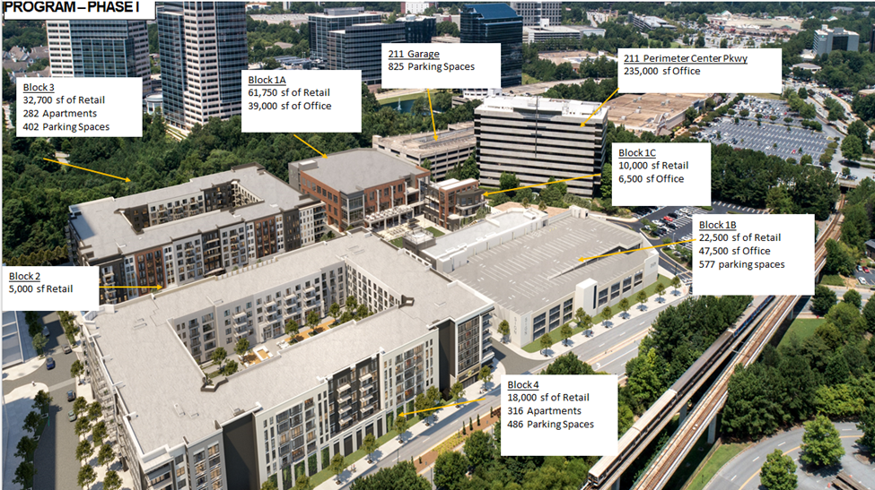
84 Perimeter MOU Modifications
- Section 3.15
  - Currently, the MOU requires that the “lessee” of a residence be age 55 or older. JSJ is requesting that be revised to state an “occupant” be aged 55 or older, which is the language used in the Fair Housing Act exemption for Housing for Older Persons. 42 U.S.C. §§ 3601-19
  - For various business reasons, a few of which are listed below, JSJ expects that many of the leases will be signed by a “lessee” who is not yet 55 years old but that the residence will be occupied by one or more “occupants.”
    - Frequently, family members or legal guardians will lease a unit on behalf of a relative. Reasons for this include lack of income verification, a child renting on behalf of older parents, a trust or conservatorship being the named lessee, etc. In addition, a spouse who is younger may be the named lessee for any number of reasons.
    - Each unit will have at least one occupant who is aged 55 or older, meeting the existing zoning requirement and goals of the City to have a 55+ community without unnecessarily restricting potential residents.
- Section 4.1
  - As currently drafted, the MOU requires that JSJ close its bond transaction by December 31, 2021. JSJ is requesting that this be extended to December 31, 2022. While they are making progress with investors and planning, they do not expect to have their financing completely finalized in order to make a year-end closing.

Campus 244
The Inducement Resolution contemplates our normal tax savings schedule.

RESOLUTION OF THE DUNWOODY DEVELOPMENT AUTHORITY APPROVING IN PRINCIPLE THE ISSUANCE OF ITS INDUSTRIAL DEVELOPMENT REVENUE BONDS IN MULTIPLE SERIES, SERIES A, FOR PHASE I OF A MIXED-USE PROJECT, HAVING A MAXIMUM PRINCIPAL AMOUNT NOW ESTIMATED NOT TO EXCEED $202,000,000, SERIES B, FOR PARKING, HAVING A MAXIMUM PRINCIPAL AMOUNT NOW ESTIMATED NOT TO EXCEED $34,000,000, SERIES C, FOR PHASE II OF A MIXED-USE PROJECT, HAVING A MAXIMUM PRINCIPAL AMOUNT NOW ESTIMATED NOT TO EXCEED $110,000,000, TO FINANCE A CAPITAL PROJECT IN DUNWOODY, GEORGIA; AUTHORIZING THE EXECUTION OF A LETTER OF INTENT AND INDUCEMENT AGREEMENT, AND FOR ANY RELATED PURPOSES.
PROJECT SUMMARY

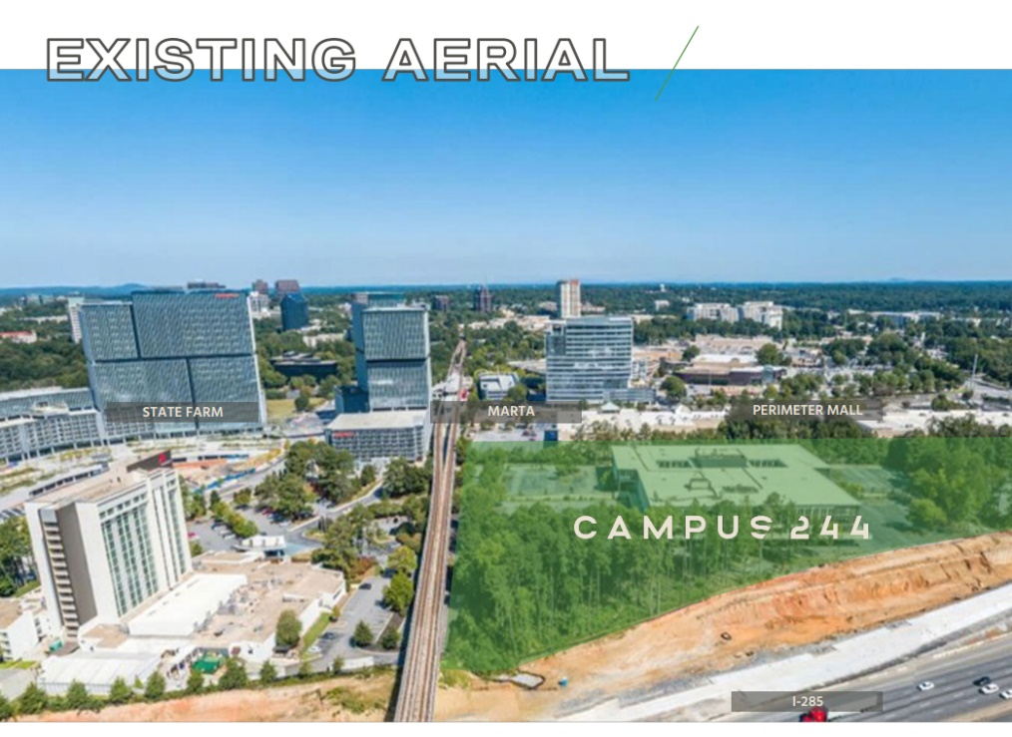
The Project is a two-phase mixed-use commercial development (approximately 681,000 total square feet) and an economic development project under O.C.G.A. § 36-62-2(6)(N), estimated to create approximately 2,651 jobs, and consisting of multiple components, being (a) the renovation of approximately 268,000 square feet of existing office space, (b) the addition of approximately 100,000 square feet of office overbuild and office space in an existing office building, (c) the construction of a new office building, consisting of approximately 200,000 square feet of office space, (d) a hotel consisting of approximately 85,000 square feet and 145 keys, (e) four or five restaurants, consisting of approximately 18,000 square feet, and (f) improved pedestrian walkways and streetscape to provide better access to public transportation (the Metropolitan Atlanta Rapid Transit Authority, or “MARTA”), as well as potential structure design enhancements to MARTA. The Project also includes, as part of Phase I, parking deck improvements and the creation of approximately 2,000 parking spaces to serve the portions described above. Phase II of the Project, will include the construction of a separate office tower and parking deck.
